**MY SQL(TASK 2)**

**1.To find the address (Location_ id, street _ address, city, state _ province, country_ name) of all thee departments by using natural join.**

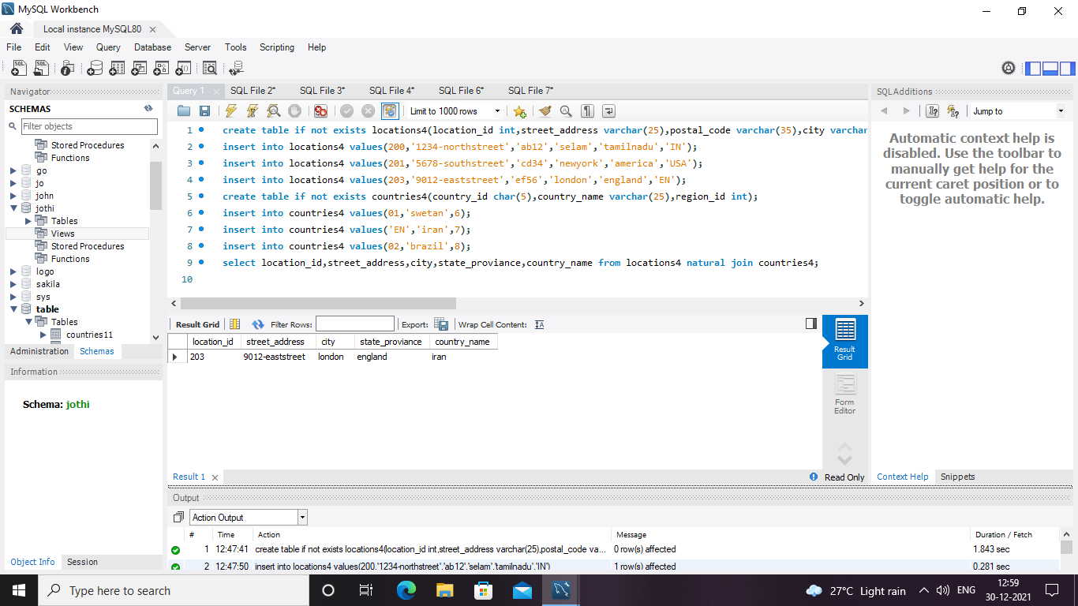

**Output:**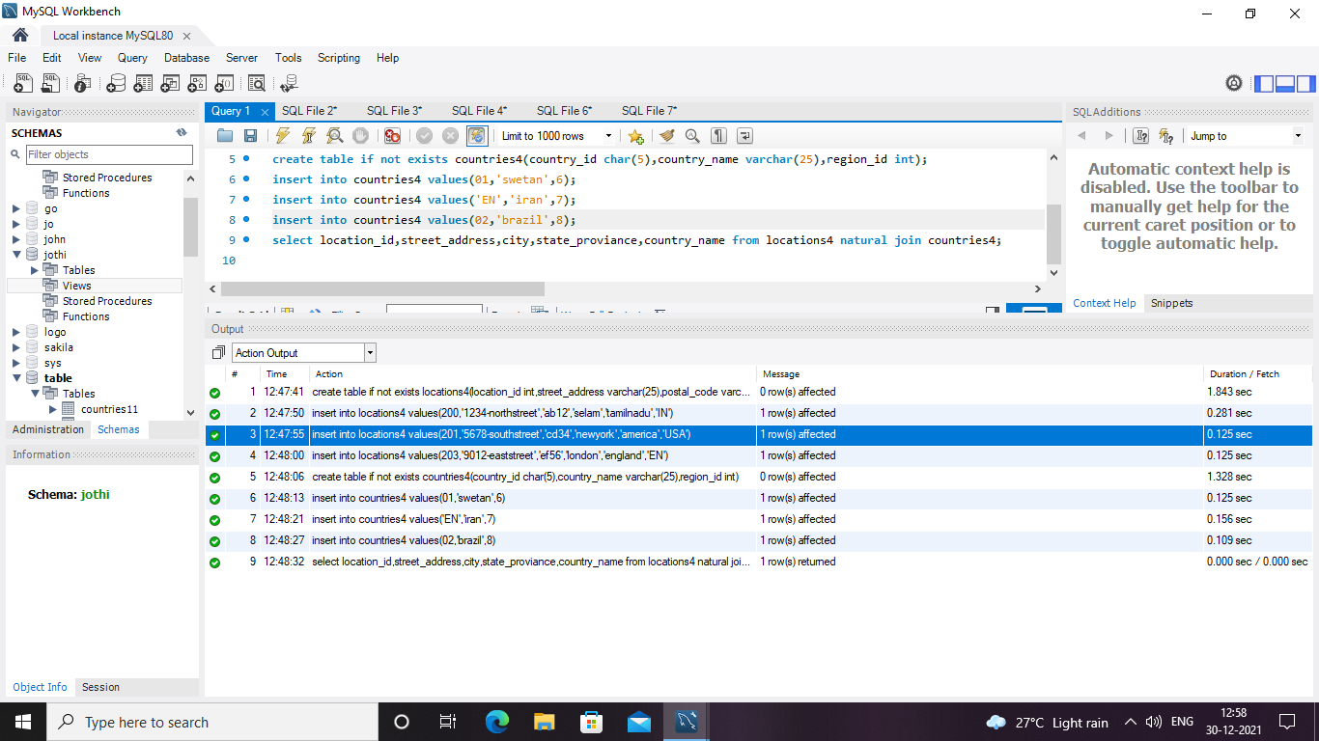

**2. To find the name (first_ name, last_ name) department_ id and name of all the employees.**

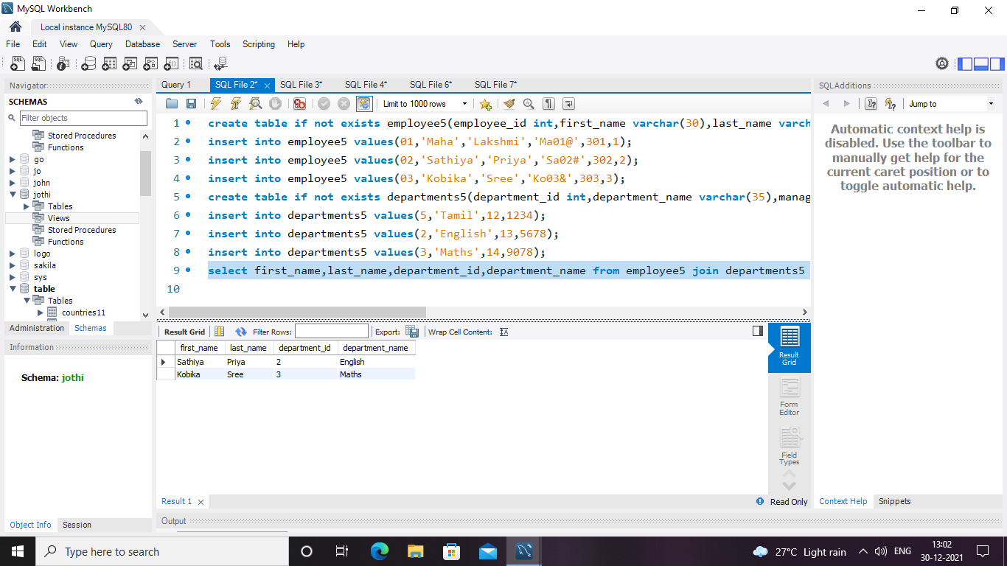

**Output:**

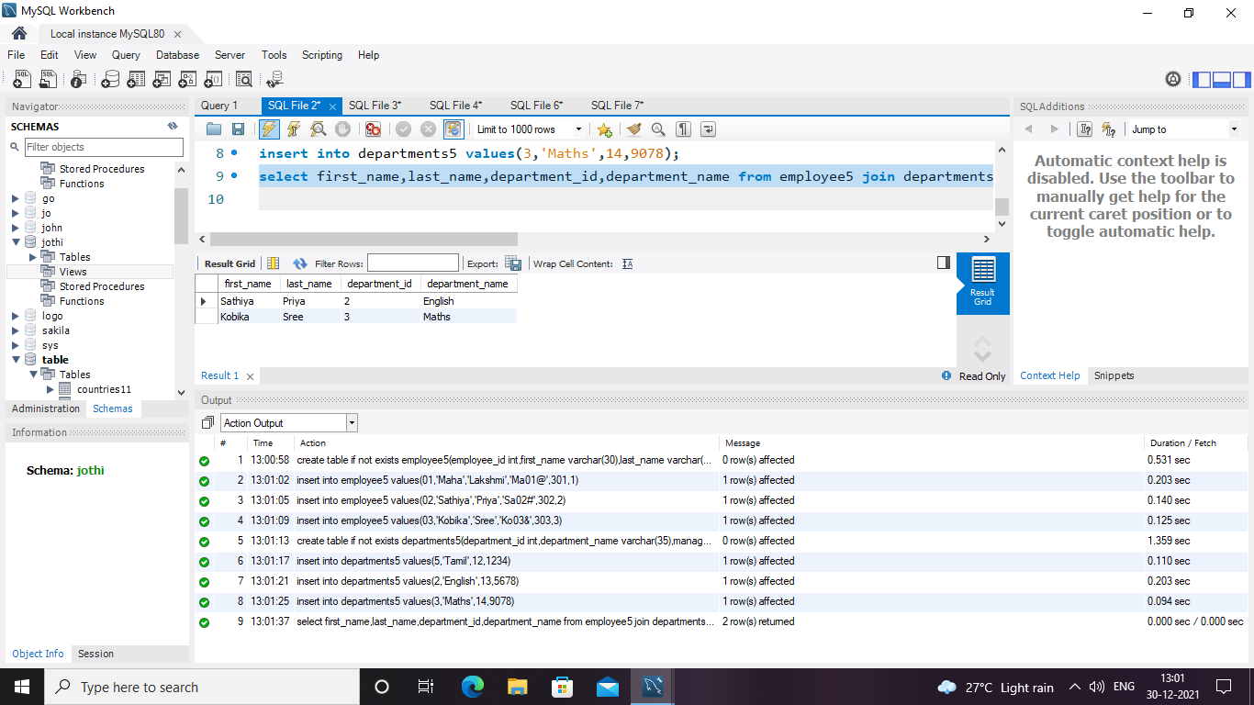

**3.To find the name (first_ name, last name), job, department_ id and name of the employees who works in London.**

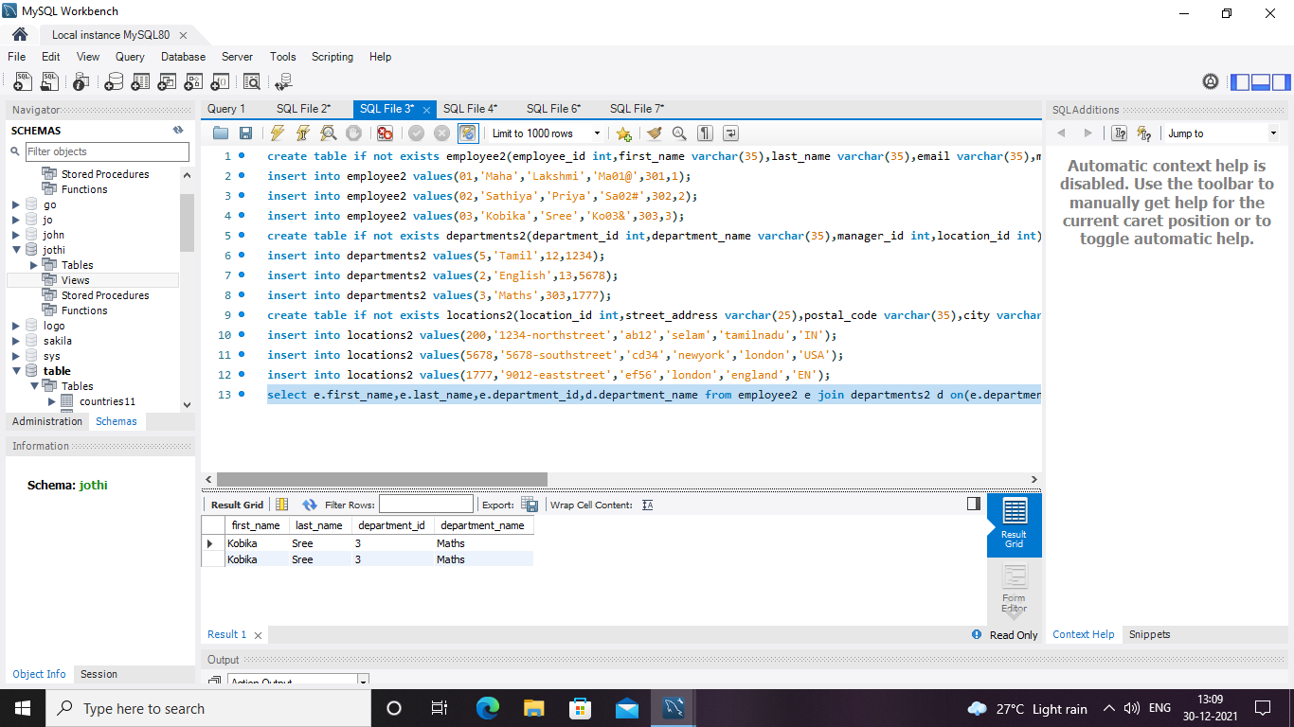

**Output:**

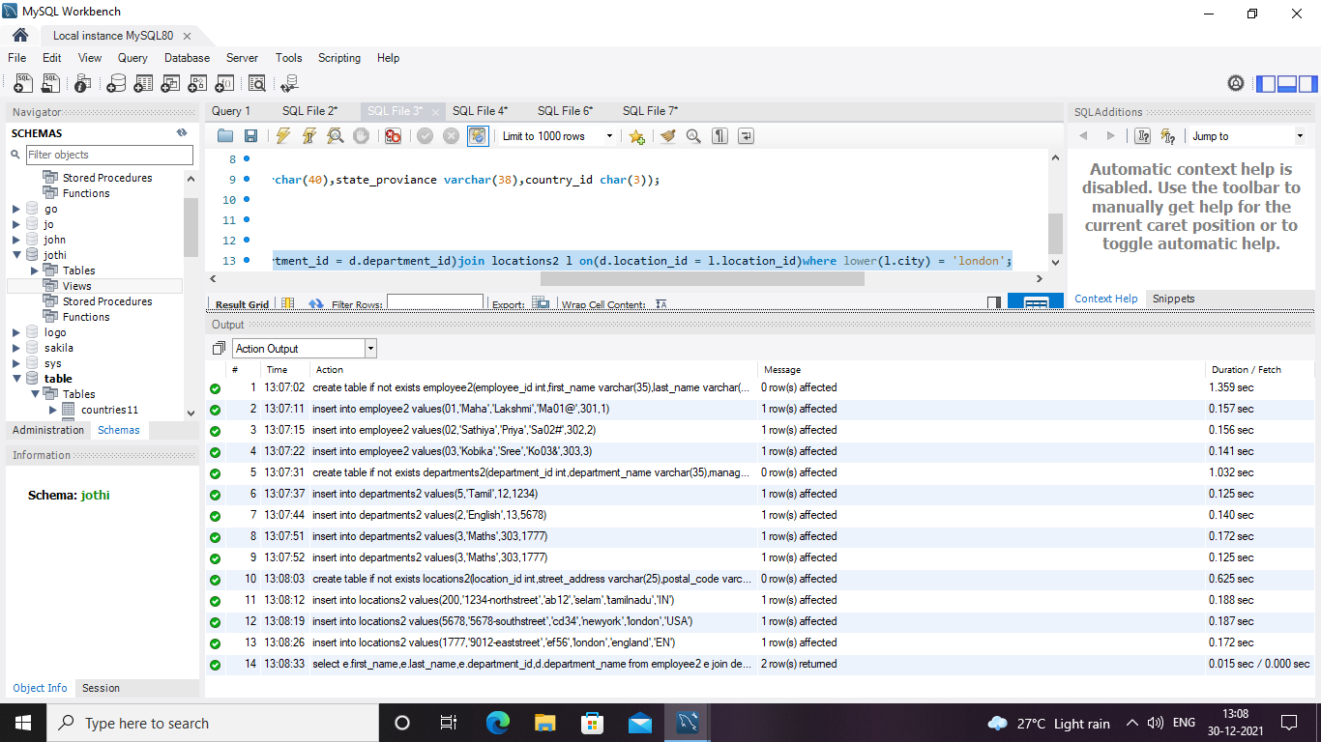

**4.To find the name (first_ name, last_ name) and the salary of the employees who have a higher salary than the employee whose last_ name =’Laskhmi’.**

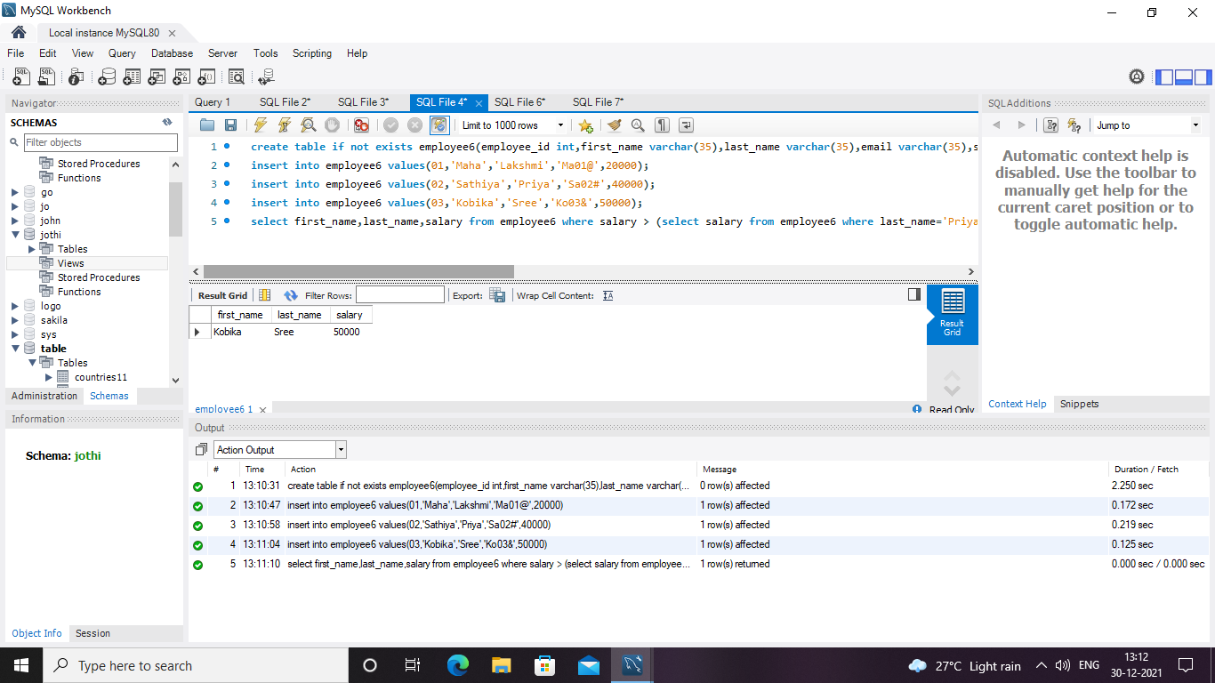

**5.To find the (first_ name, last _ name) of the employees who have a manager and worked in a USA**

**Based department.** 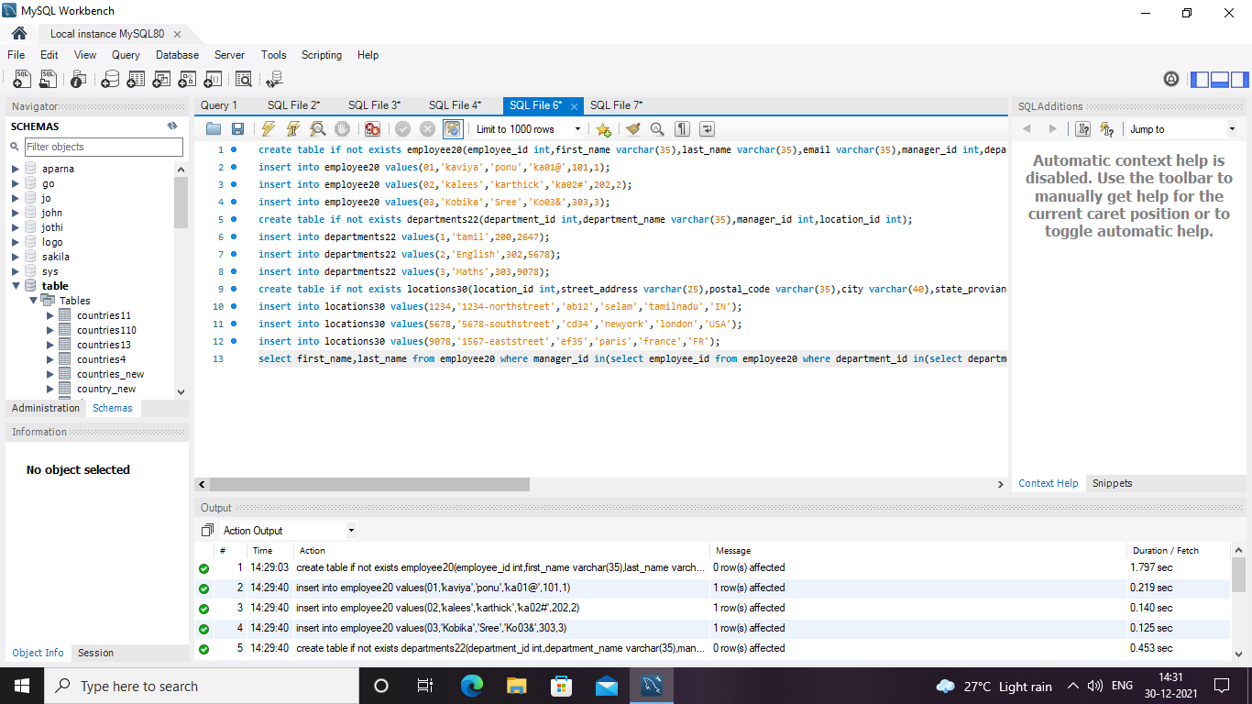

**Output:**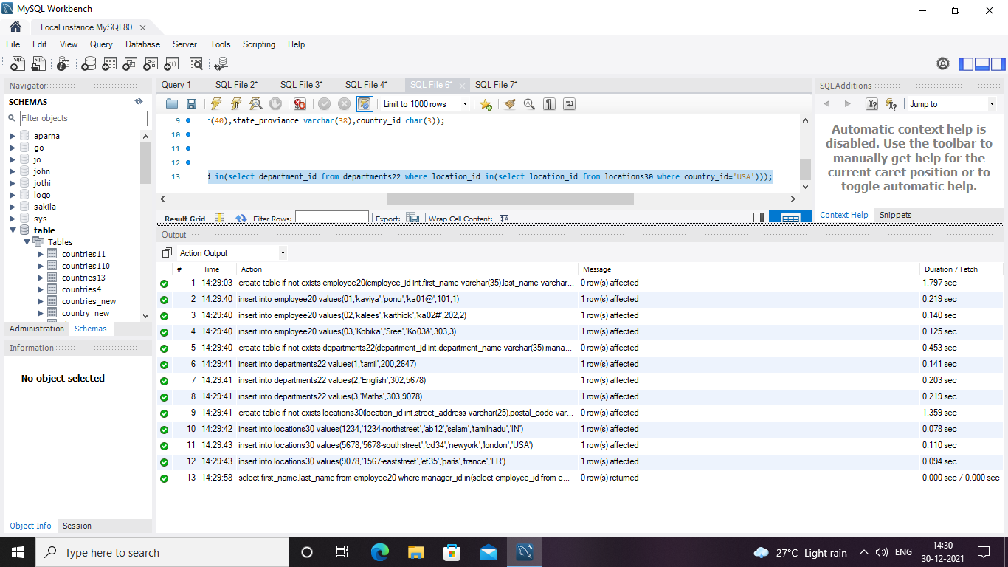

**6.To find the name (first_ name, last_ name) of the employees who are managers.**

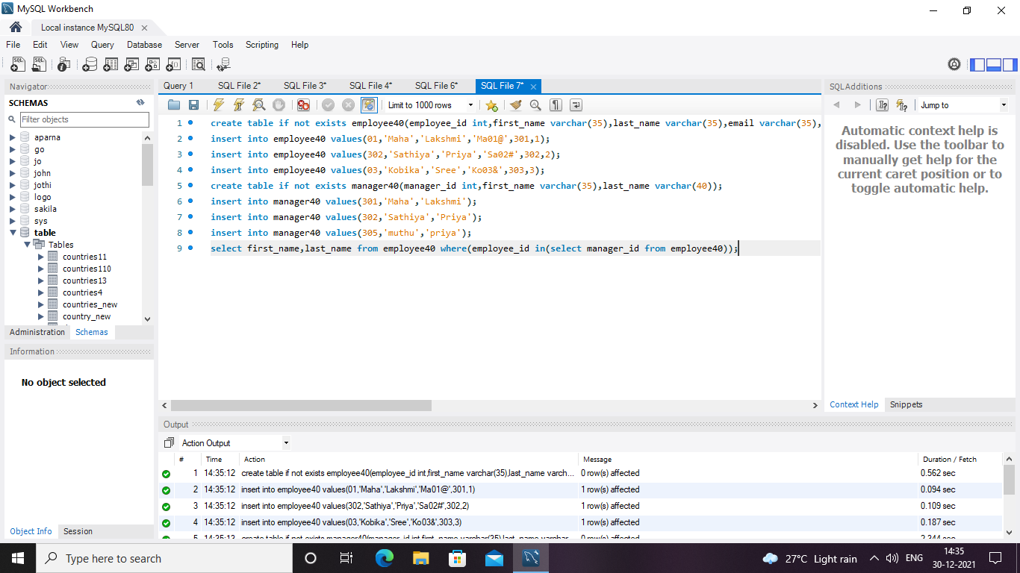

**Output:**